**Property- Section -> Flowaction - > Flow**

**How to Map User Interface Design in Flow?**

Ans: By Using Flowaction Rule we can Map User Interface Design in Flow

**Flow action Rule:**

**Flow action is a Process Rule ( Process -> Flowaction )**

**Flowaction is an instance of Rule-Obj-Flowaction**

**Purpose of Flowaction: It is a Container of Section ( Section we will call in Flowaction Rule), When ever you are using UI Design in Flow then We need to Create Flowaction for the section. In Work Flows UI can be added only through Flowaction Rule.**

**In Flowaction  -> we can add additional Actions for the UI design( Section)**

**Additional Actions-> Validations & Business Logic ( Activity & Data transform)**

**Create a Flowaction & Add Customer Details section inside Flowaction:**

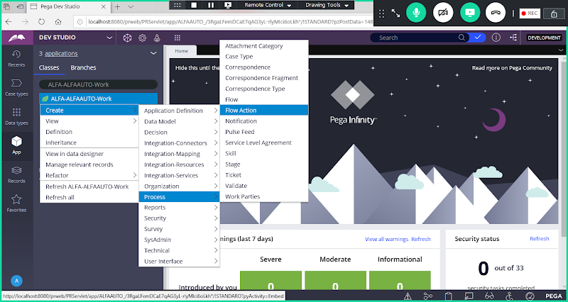

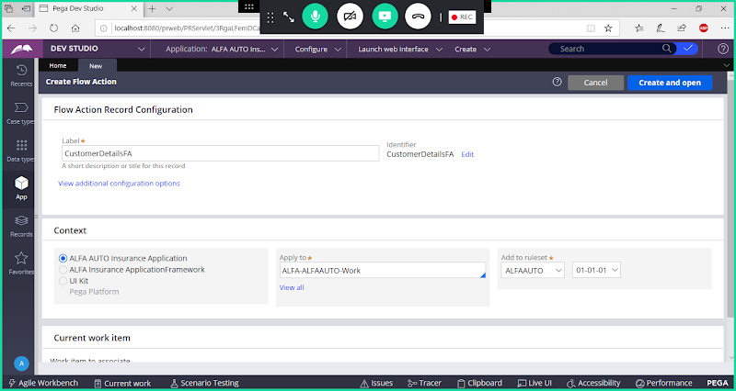

**Open**

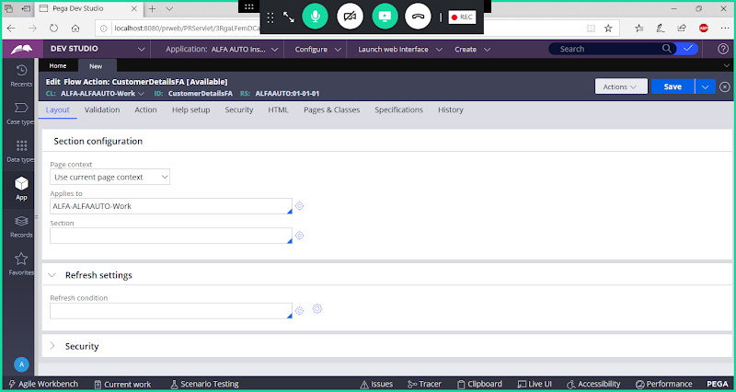

**Give section Name**

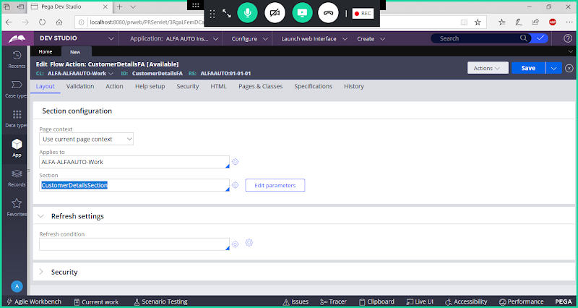

**Save Flowaction**

**=====================**